Code Crawler
Software Requirements Specification

Version 1.13

Revision History
Date | Version | Description | Author
11/6/2004 | 1.0 | Initial entry of Search requirements | David Peerenboom
11/16/2004 | 1.1 | Revision | David Peerenboom and Kinis Meyer
11/19/04 | 1.2 | Error table and insertion of comments from Martin and Nikolay | Kinis Meyer and David Peerenboom
11/16/2004 | 1.3 | Added index module requirements | David Peerenboom and Kinis Meyer
11/21/2004 | 1.4 | Move error table items to requirements and incorporated Nikolay’s comments from 11/20/04 | Kinis and David
11/21/2004 | 1.5 | Add Code Analysis and extension to Index module | Kinis and David
11/22/2004 | 1.6 | Finish moving error table items | Kinis
11/23/2004 | 1.7 | Turn off track changes | David
12/4/2004 | 1.8 | Update with review findings | Kinis and David
12/7/2004 | 1.9 | Add language support and several other corrections from the document review with OnLine Commons. | Kinis and David
2/27/2005 | 1.10 | Modify 3.1.1.4.3.5.1.1 for non-void codebanks | Kinis and David
4/23/05 | 1.11 | Rectify content with end-of-semester CC product; remove 3.1.3.2.2.7; | David and Kinis
4/30/05 | 1.12 | Added changes from Martin | Kinis
5/4/2005 | 1.13 | Some corrections of already implemented features | Nikolay

Table of Contents
1. Introduction 4
1.1.1 Problem Statement 4
1.1.2 Product Overview 4
1.2 Purpose 5
1.3 Scope 5
1.4 Definitions, Acronyms and Abbreviations 5
1.5 References 5
1.6 Overview 5
2. Overall Description 5
3. Specific Requirements 5
3.1 Functionality 5
3.1.1 User Interface (UI) module 5
3.1.2 Indexing module 8
3.1.3 Search module 9
3.1.4 Code Analysis Module 9
3.2 Usability 10
3.2.1 User Interface Usability 10
3.3 Reliability 11
3.3.1 Accuracy of the index for searching 11
3.3.2 Conformity to user settings 11
3.3.3 Atomicity and availability of the search 11
3.3.4 Precision of the search results 11
3.4 Performance 12
3.4.1 Response Time for displaying the matching query results 12
3.5 Supportability 12
3.5.1 Coding Standard 12
3.5.2 Addition of support for new languages 12
3.6 Design Constraints 12
3.6.1 Third Party Software Components 12
3.6.2 Time constraints 12
3.7 On-line User Documentation and Help System Requirements 12
3.7.1 User Help Page 12
3.7.2 Administrator on-line documentation 12
3.8 Interfaces 13
3.8.1 User Interfaces 13
3.8.2 Hardware Interfaces 13
3.8.3 Software Interfaces 13
3.8.4 Communications Interfaces 13
3.9 Licensing Requirements 13
3.10 Legal, Copyright, and Other Notices 13
3.11 Applicable Standards 13
3.11.1 Interoperability 13
4. Supporting Information 14
4.1 UI Prototypes 14

Software Requirements Specification

Introduction

Problem Statement
Large-scale software development and maintenance presents many challenges to developers. As the code base grows, so do the difficulties of staying up to date with the code, finding the right place for implementing new requirements, or trying to fix existing bugs. In addition, as code size increases, sometimes documentation does not get updated or is missing altogether, which makes training new developers difficult and time consuming.

When wandering through the code, developers often use grep utilities to find a particular piece of code. These utilities let developers search source files for a match with a regular expression, and while powerful, they have three disadvantages. First, writing a regular expression for a search necessitates at least some knowledge about what you are searching for – for example, the prefix of a variable name or that the variable ends with a number. Second, the results returned from a grep are all the matches to the given regular expression and in that respect are all equally relevant. This means a developer might get hundreds of results and have no idea which one to look at. Third, grep utilities are part of the operating system or are integrated within an IDE and the results cannot be viewed from the web. These days, when so many open source projects are developed over the Internet, searching source code directly from a web browser seems natural.

With the advance of the Internet, web search engines have become an irreplaceable tool for developers. They are not as precise and powerful as grep utilities, but address their disadvantages. Web search engines allow inexact matches, rank the results by relevance, and display them in a web-viewable form. However, these search engines are usually geared toward text searches and do not work well for source code.

Search engines have drawbacks themselves. In programming languages, identifiers usually combine several words (i.e. ListArray or basic_string), but to search engines a word is just a word. If search engines were able to split an identifier into its composing words, then search engines would be more useful to developers and programmers. Search engines also compute a relevance score for a particular result based, in part, on how many occurrences of the search keywords appear in the results. In source code, however, there is an implied understanding that some occurrences are more important than others. For example, when searching for "Foo", a document with several occurrences of a local variable "Foo" is usually less relevant than a document declaring a class "Foo". Text search engines, of course, do not have the knowledge to perform this analysis. This lack of knowledge also means developers searching for a keyword with particular semantics; say function "Foo" might get results for class "Foo" or variable "Foo" or any other "Foo". A nice addition to the search engine query syntax would be to specify the semantics of the keyword being searched, for example, "function: Foo".

A successful solution would combine the best of web search engines and grep tools, and extend it with knowledge about programming language syntax and source code semantics to allow more intelligent searches that more accurately determine the relevance of search results.

Product Overview
CodeCrawler will be a system that makes searching source code as easy as searching the Internet and as powerful as using a grep tool. CodeCrawler will provide a web interface that allows users to submit search queries using regular expressions (like grep), using keywords (like web searches), or using special programming specific extensions. The results returned from the searches should be ranked by relevance, taking into account source code semantics (class, method, variable, etc.) and user’s preferences, and should point to the original source code. The system should be easy to use, configurable, and responsive. It should support as many programming languages as possible and should be easily extendable with new ones.

Purpose
The purpose of this Software Requirements Specification document is to provide a complete and comprehensive description of the CodeCrawler system’s functional and non-functional requirements.

Scope
The scope of this Software Requirements Specification is the entire CodeCrawler system. The requirements are derived from the vision statement, use case model, and discussions, emails, and meetings of the development team.

Definitions, Acronyms and Abbreviations
See CodeCrawler Glossary.

References
- Vision Statement for CodeCrawler
- Use Case Model for CodeCrawler

Overview
The remaining portion of the document contains the functional requirements in section 3.1 organized into modules from a top-down point of view for the system, the non-functional requirements in sections 3.2-3.5, possible design constraints in 3.6, documentation in section 3.7, interfaces in 3.8, legal, licensing, and standards in 3.9-3.11, and supporting information including user interfaces prototypes in section 4.

Overall Description
The users of CodeCrawler are expected to be software developers and programmers familiar with the syntax of at least one programming language and regular expressions. CodeCrawler requires an administrator to initialize and maintain the indexes and connections to the Codebanks for accessing the source code.

Specific Requirements

Functionality

User Interface (UI) module

Search Page

The system will allow the user to enter a query with the default search configuration.

The system will allow the user to go to the Advanced Search page.

The system will allow the user to go to Search Help page (see online documentation section below).

The system will provide an easy-to-remember URL to reduce the number of users mistyping the URL for the search page.

Results Display Page

The system will display a header with “Results 1 – X of Y”.

The system will display the last indexed on date. (Moved to version 1.1)

The system will display for each result:

Ranking/Score

Filename and language

Codebank’s or project’s name (Moved to implementation of version 1.1)

Code snippet (approx. 2 lines) with the query match highlighted

File size (XXX bytes)

Date of last modification of the file

Link to view the source code file in your browser

Link to download the file

If the index search fails, then the system will display an error page.

If fetching a file fails, then the system will log an error and not display the code snippet.

If the highlight formatting fails for the code snippet, the system will log an error and display the original, unformatted code snippet.

If no matches are found, the system will display a “No Items Were Found” page.

If the file has been modified since the last index was built, the system will log a warning, and the system will display the old indexed version of the file.

If the file is binary, then the system will not display the code snippet and the link to view the source code will go to a blank web page.

If the developer enters an empty query, the system will display the search page again. If the developer enters an invalid query, the system will display an error message.

View Code Page

The user will be able to click on the link or file name above the code snippet to view the code in the browser.

The source code will be displayed formatted with highlighting of the search query throughout the code.

If fetching a file fails, the system will log an error and display an error message to the developer.

If the file is binary, the system will display a blank page to the developer.

If the formatting fails for the code, the system will display the original, unformatted code.

Configuration Web Page

The role of Administrator shall be a user with an administrative role in Tomcat or whichever server being used.

The Administrator is the only one allowed to control the system.

The Administrator shall be required to login by entering both an ID and a password that is verified by the server.

If the Administrator fails to enter a correct ID or password, the system shall prompt the user to retry the ID entry.

If the Administrator fails to enter a correct ID or password on the third consecutive try, the system shall lock-out further attempts in that browser.

The system control settings are:

Configure codebank access and location for developers.

Verify login information for CVS and WebDAV codebanks.

Configure index access and location.

Schedule for re-indexing intervals.

Maintain mapping between files extensions and programming languages.

Add support for new languages.

Select whether an unsupported file extension will be skipped during indexing or treated as plain text.

Select how to handle a file extension that matches multiple programming languages.

Select the scoring or relevance factors for each category i.e. if matches that are classes should count for more in the result score than a local variable.

Set default number of results to display per page.

The system shall allow the Administrator to confirm the control settings by clicking on Change Configuration.

If the choices made by the Administrator to change the settings are invalid, then the system will display an error message and allow the Administrator another attempt.

If the choices made by the Administrator to change the settings are valid, then the system will display a confirmation message.

The system shall update the control settings when the Administrator gives confirmation to change the configuration CodeCrawler.

If the configuration change concerns the schedule intervals for indexing, the change will take effect after the top of the hour. The Administrator can manually run the indexer if the index(s) need to be updated before then.

If the changes to the configuration require that the indexing be aborted and the index(es) be deleted, then the system will abort indexing and delete the index(es).

Advanced Search Page

The Advanced Search Page shall allow the user to select language types to be searched.

The supported languages consist of the following.
Assembler
ASP
Awk
BETA (moved to version 1.1 implementation)
C
C++
C#
COBOL
Eiffel
Erlang
Fortran
Haskell (moved to version 1.1 implementation)
HTML
Java
JavaScript (moved to version 1.1 implementation)
Lisp
Lua
Make
Pascal
Perl
PHP
PL/SQL
Python
REXX
Ruby
Scheme
Shell scripts (Bourne/Korn/Z)
S-Lang (moved to version 1.1 implementation)
SML (Standard ML)
Tcl
Vera (moved to version 1.1 implementation)
Verilog (moved to version 1.1 implementation)
Vim (moved to version 1.1 implementation)
YACC

Indexing module

Indexing module shall accept commands from the Configuration module.

Indexing module shall accept a command from the Configuration module to update the indexes. Indexing module shall accept a command from the Configuration module to update the index associated with a named Codebank. (moved to version 1.1 implementation)

Indexing module shall execute a command from the Configuration module to update the indexes. Indexing module shall execute a command from the Configuration module to update the index associated with a named Codebank. (moved to version 1.1 implementation)

The Indexing module shall log an error if a file fetching fails.

If the indexing fails, the system logs the error, aborts indexing and deletes the partial index.

If a file extension does not match any CodeCrawler supported programming language, the system will log a warning and either skip the file or treat it as plain text whichever is specified in the configuration settings. The default setting is to treat the file as plain text.

If a file extension matches multiple programming languages, the system will log a warning and handle the file as specified in the configuration settings.

If the context extraction fails, the system will log an error and treat the file as plain text.

If a file cannot be added to the index, the system will stop the indexing process and log an error.

When the Indexing module has successfully updated an index, it shall replace the previously existing index with the updated index.

The Indexing module shall delete the existing indexes and update the indexes. The system will be unavailable during this period for searching on all the indexes.

The Indexing module shall wait until existing index is free of accesses before it shall replace the previously existing index with the updated index.

The Indexing module shall delete the deprecated index only after all prior searches are completed.

The Indexing module shall abort indexing if changing the index location fails.

The Indexing module shall log an error if the deletion of the pre-existing index fails.

Indexing module shall notify the Administrator of the status of the updating of the index.

The notification to the Administrator of the index updated and completion will be via the console window in Eclipse if open.

The notification to the Administrator of the index updating shall be by email. (moved to version 1.1 implementation)

The notification to the Administrator of the index updating shall contain status information.

If the email notification fails, then the system will log an error and save the error log locally. (moved to version 1.1 implementation)

Indexing module shall accept commands from the Search module.

Indexing module shall accept a command from the Search module to search the index associated with a named Codebank. (Note: the command contains search criteria as defined in 3.1.3.1.2.1.) (moved to version 1.1 implementation)

The Indexing module shall maintain a Status Log.

The Status Log shall include information of any errors that were encountered on any indexing operation.

All entries in the Status Log shall be time stamped.

The Indexing module shall record all actions by the Administrator in the Status Log.

Search module

Basic Search

The developer shall be able to enter a query with search criteria on the Search page.

When search criteria are entered into the Search page by the developer, the Search module shall parse and test the entry for validity.

Validity shall be defined by the following grammar:

word → any case insensitive word

regex → any regular expression without spaces

category → filename | function | variable | class | language

qterm → category= qexpr | qexpr

qop → and | or | not |

query → qterm qop query | qterm

qexpr → word | #regex | ( query )

If the query is invalid, the system shall display an error message.

If the index cannot be read, the system shall display an error message.

Advanced Search

The developer shall be able to select the Advanced Search option on the Search page.

The Search module shall present to the developer a Default Search Configuration on the Search page.

The Search module shall permit the developer to modify the Search Configuration on the results page.

The Search module shall permit the developer to change the number of results displayed.

The Search module shall permit the developer to select a textual search with all the words.

The Search module shall permit the developer to select a textual search with the exact phrase.

The Search module shall permit the developer to select a textual search with at least one of the words.

The Search module shall permit the developer to select to search on Methods or Classes.

The Search module shall permit the developer to select the language extension(s) to search on.

Code Analysis Module

The list of mandatory semantic categories shall be:

“size”

“modified”

“indexed”

“filename”

“contents”

“language”

The list of semantic categories shall be:

“function”

“class”

“variable”

“table”

“block data”

“common”

“component”

“constant”

“cursor”

“define”

“entry”

“enum”

“enumerator”

“event”

“exception”

“externvar”

“feature”

“field”

“functor”

“interface”

“label”

“local”

“macro”

“member”

“method”

“mixin”

“module”

“namelist”

“namespace”

“package”

“program”

“procedure”

“property”

“record”

“signature”

“singleton method”

“struct”

“structure”

“sub”

“subroutine”

“subtype”

“table”

“trigger”

“type”

“typedef”

“union”

”value”

The Code Analysis module shall return a list of entries as follows:

The Code Analysis module shall return the identifier being described.

The Code Analysis module shall return the line number in the source file.

The Code Analysis module shall return the kind of semantic construct this identifier represents. (TBD).

Usability

User Interface Usability

The CodeCrawler user interface for the search page and advanced search settings page will be patterned after the Google website. The CodeCrawler’s UI will be familiar to developers and administrators and have the option to search with the default settings, view the Advanced Search options page, or view CodeCrawler’s help page. A search submission, help page, or search options page will not be more than one click away from the search page. First time users will be able to successfully search on a project using the user set configurations within two attempts.

CodeCrawler will provide specific error messages for all the extensions listed in the Use Case Model. The error messages will notify the user of the problem and a suggested solution if appropriate. (moved to version 1.1 implementation)

Reliability

Accuracy of the index for searching

The index for the projects will be updated at regularly scheduled times set by the Administrator and will never be older than 1 hour by default to ensure the search results are relevant and timely. Users will be able to send requests to the Administrator to have an index be updated at intermediate times if needed.

The date and time of the index’s last update is included at the top of the result pages to make the user aware of the point in the project’s progress the index was captured. (moved to version 1.1 implementation)

If an index is lost for any reason, a new index will be re-created as soon as the Administrator can determine the problem and whether the project’s source code is available for indexing.

Conformity to user settings

The results will be displayed according to the user’s settings or the default settings.

Atomicity and availability of the search

Searches will not be available during re-indexing and if a search is executed during a re-indexing, only a partial list of results could be returned.

Searches will be performed only on the stable indexes available when the search begins. While the re-indexing is being done, searches will be conducted on the last stable version of the index. When the search and the re-indexing are both completed, the new index will become the searchable index for the project. While the index paths are being updated, searches will be unavailable for as short a period of time as necessary to change the index path.

Precision of the search results

In the event that a user chooses a code snippet to view from the result’s page that has been deleted or was from a file that has been deleted since the index was updated, the developer will be shown the file as it appeared at the time of the last indexing. For version 1.1’s implementation, an error page will be displayed stating the reason the deleted code cannot be viewed. The users prefer to see all results even if the code has since been deleted or modified than not be aware of the match.

Performance

Response Time for displaying the matching query results

CodeCrawler will display the result page(s) to the user within 5 seconds after the query is submitted with a confidence of 95%.

Supportability

Coding Standard

Writing Robust Java Code, The AmbySoft Inc. Coding Standards for Java v17.01d by Scott W. Ambler

www.AmbySoft.com/javaCodingStandards.pdf

Addition of support for new languages

Design Constraints

Third Party Software Components

The limitations on the extensibility of the free third party software components may constrain our design.

Time constraints

Time constraints of the team next semester may affect our design.

On-line User Documentation and Help System Requirements

User Help Page

CodeCrawler will supply the developer a help web page with instructions on the following topics:

Valid search criteria including examples. (moved to version 1.1 implementation

All the options on the Advanced Search page.

Error codes (moved to version 1.1 implementation)

Administrator on-line documentation

CodeCrawler will supply the Administrator on-line documentation for the following topics:

Adding support for a new language. (moved to version 1.1 implementation)

Aborting indexing and manually deleting indexes. (moved to version 1.1 implementation

Changing configuration settings.

Setting up a new project Codebank and index.

Interfaces

User Interfaces
See Prototypes in the Supporting Information Section 4.1 below.

Hardware Interfaces
Not applicable.

Software Interfaces
Source code retrieval for results page and viewing from the following:
- CVS
- Zip format
- Jar format
- Local file system
- WebDav

Communications Interfaces
Network connection from the developer’s machine to the index storage location and the physical location of the source code files.

Licensing Requirements
Google is a registered trademark. All other product names mentioned herein and throughout the entire documentation of CodeCrawler are trademarks of their respective owners.

Legal, Copyright, and Other Notices
CodeCrawler will include all copyrights and licensing information from third party software used in any way in the implementation and maintenance.
- Tomcat and Lucene: http://www.apache.org/licenses/LICENSE-2.0
- CTags: http://sourceforge.net/projects/ctags
- WebCPP: GNU Public License

Applicable Standards

Interoperability

CodeCrawler will conform to the standards of any third party software to ensure interoperability.

Supporting Information

UI Prototypes

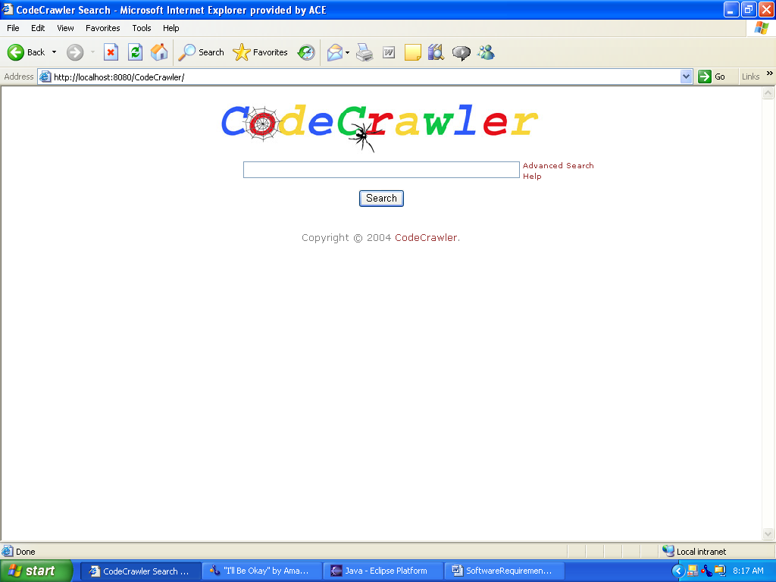
Figure 1 - Search UI Prototype

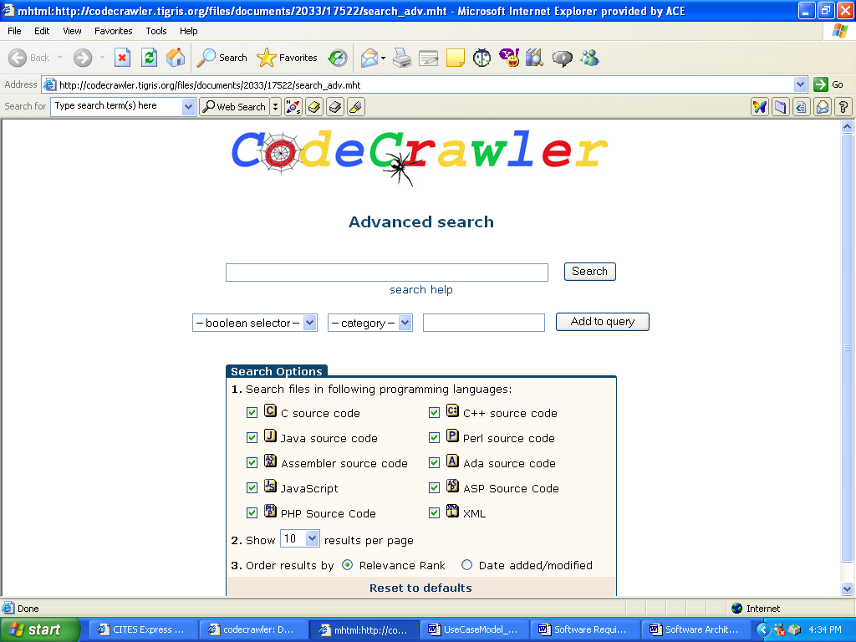
Figure 2 - Advanced Search UI Prototype
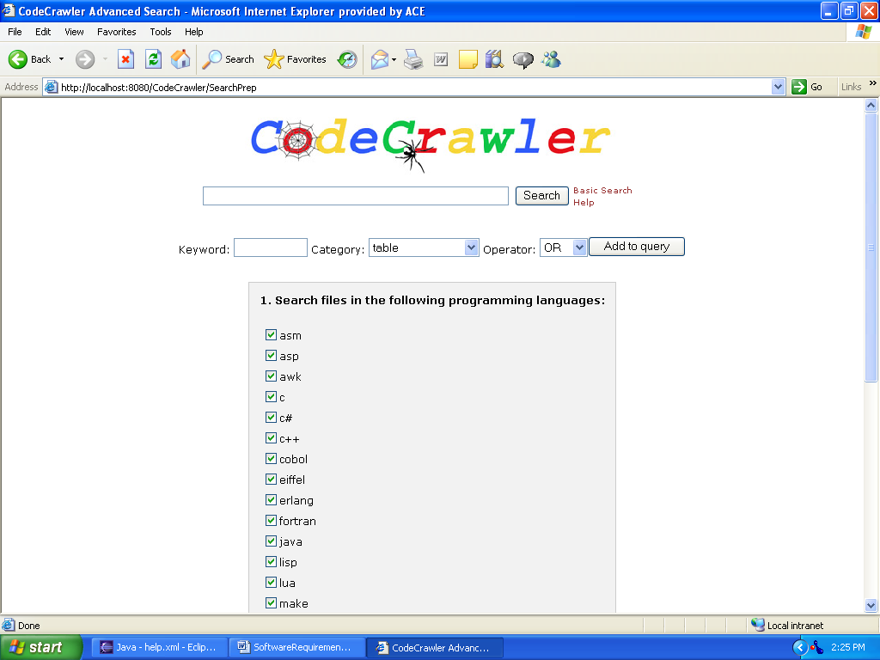
Figure 3 - Advanced Search UI
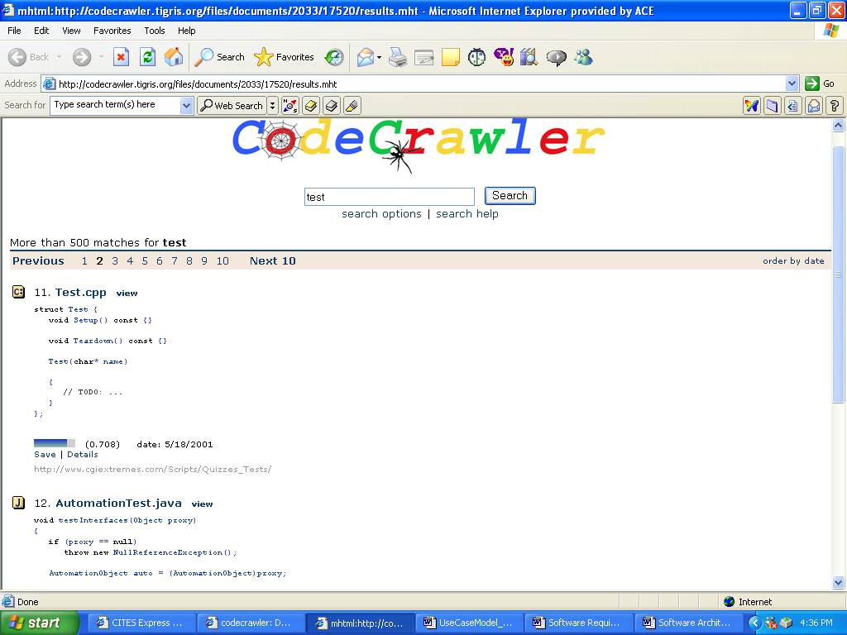
Figure 4 - Results UI Prototype

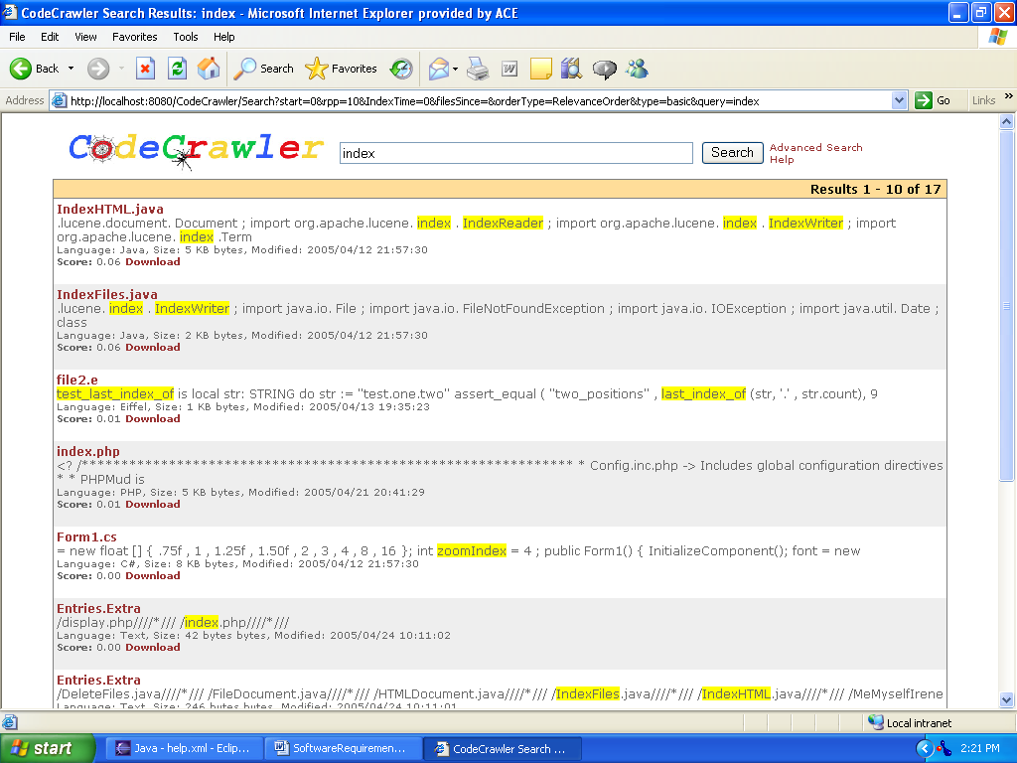
Figure 5 - Results UI

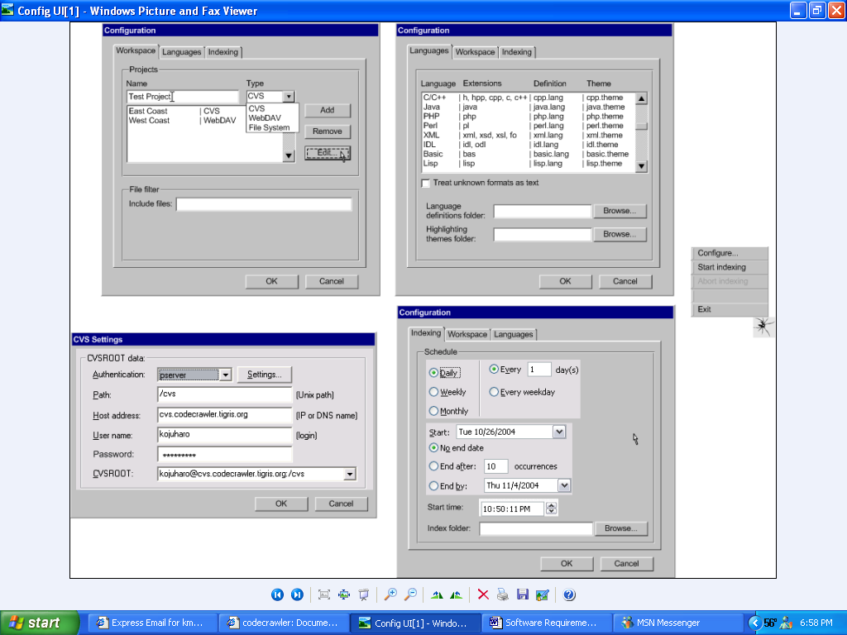
Figure 6 - Administrator's Configure UI Prototype

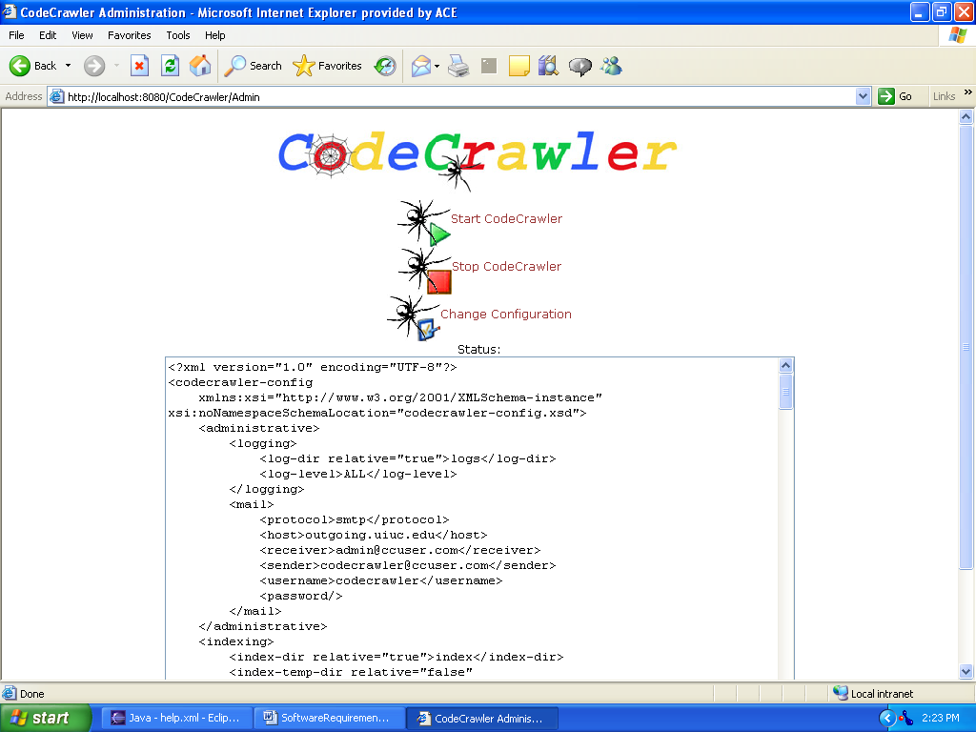
Figure 7 – Administrator’s Configure UI

